**Crime update**

During the month of August 2023 Hoton had no crimes reported. These figures do not include private domestic related incidents or harassments.

No other significant crime patterns have been identified. For more detailed data, please visit <https://www.police.uk/>

**Keep up to date with our latest police communications by signing up to** [**www.neighbourhoodlink.co.uk**](http://www.neighbourhoodlink.co.uk) **where you will receive real time updates via email.**

**Here you will find our latest survey ‘ Your Views Matter ‘ which gives you the opportunity to address any police and partner agency intervention needed across Charnwood.**

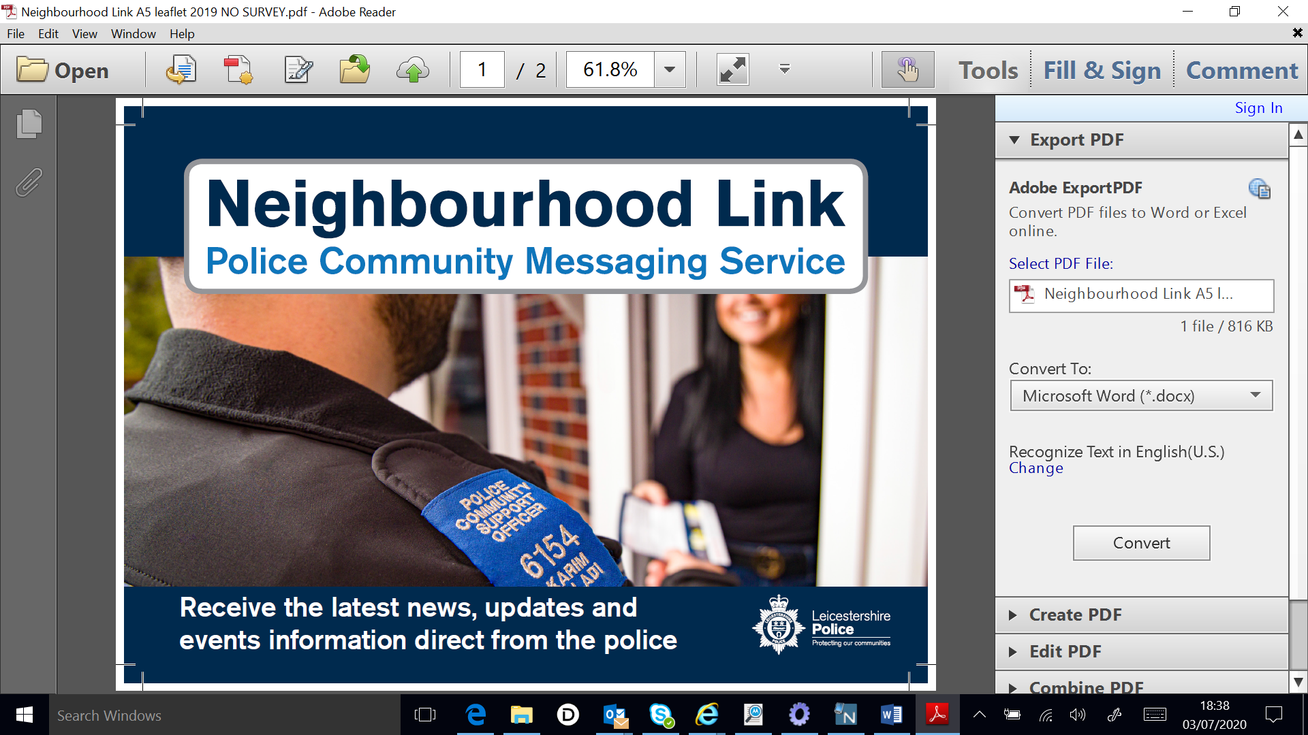

**Police Advice**

# Checklist for securing your home when you leave it

It’s vital to leave your home secure whenever you leave it. Getting into an ‘exit routine’ can help ensure that you don’t forget obvious, important things, like not leaving your valuables near windows, or no lights on if it will be dark before you get home. Here’s what you should do just before you go out.

## **Become a creature of habit**

Try to get into the habit of following your own course of action when you lock up your home. This will ensure that you don’t forget anything.

Here’s what we recommend you do before you go out:

* close and lock all your doors and windows, even if you’re only going out for a few minutes
* double-lock any door
* make sure that any valuables are out of sight
* keep handbags away from the letterbox or cat flap and hide all keys including car keys, as a thief could hook keys or valuables through even a small opening
* never leave car documents or ID in obvious places such as kitchens or hallways
* in the evening, shut the curtains and leave lights on
* if you’re out all day, then it’s advisable to use a timer device to automatically turn lights and a radio on at night
* set your burglar alarm
* make sure the side gate is locked
* lock your shed or garage
* lock your bike inside a secure shed or garage, to a robust fitting bolted to the ground or wall, like a ground anchor

## **Going away?**

Here are five tips to help you keep your home and belongings stay safe while you’re away:

1. if you’re off on holiday and wish to post anything on social media, make sure your posts aren’t public and that they’re only seen by your friends
2. leave lights and a radio on a timer to make the property appear occupied
3. get a trusted neighbour to keep an eye on your property or join a Neighbourhood or resident Watch Scheme
4. consider asking your neighbours to close curtains after dark and to park on your drive
5. remember to cancel newspaper and milk deliveries

**Neighborhood update:-**

**To receive local news, updates and events information via email sign up to our Neighbourhood Link System at** [**www.neighbourhoodlink.co.uk**](http://www.neighbourhoodlink.co.uk)

Children & young people can also call child line in confidence on 0800 1111 for advice.

Action Fraud helpline: 24/7 – On 0300 123 2040.

**Your beat team**

SGT 2996 Tom Else

PC 1172 Sam Bhati

PCSO 6580 Naomi Sharpe

PCSO 6866 Sarah Wright